Insert your name, centre number and candidate number into the header above.
Save this evidence document as evidence_ followed by your centre number_ candidate number. For example: evidence_ zz999_9999.doc
Screenshots or program listings must be copied into appropriate cells in the following tables.
Examiners must be able to read the contents including any screenshots without the use of a magnifying glass. Answers that are not readable or missing will not be awarded any marks.
Save this evidence document at regular intervals, for example, every 10 minutes.
Question 1
Part 1(a)
{Copy and paste program code listing for question 1(a) here}

def ReadData():
try:
f=open("Data.txt", 'r')
DataArray=[] # DECLARE: DataArray: ARRAY[0:44] OF STRING
for item in f:
DataArray.append(item.strip())
f.close()
except IOError:
print("File not found.")

return DataArray

Part 1(b)(i)
{Copy and paste program code listing for question 1(b)(i) here}

def FormatArray(ArrOfString):
Result=""
for data in ArrOfString:
Result+=data+' '
Result=Result[0:len(Result)]
return Result

Part 1(b)(ii)
{Copy and paste program code listing for question 1(b)(ii) here}

#main
ArrayRead=ReadData()
ConcatenatedData=FormatArray(ArrayRead)
print(ConcatenatedData)

Part 1(b)(iii)
{Copy and paste the screenshot for question 1(b)(iii) here}

Part 1(c)
{Copy and paste program code listing for question 1(c) here}

def CompareStrings(Str1,Str2):
Same=True
Count=0
Result=1
while Same:
if Str1[Count].lower()>Str2[Count].lower():
Same=False
elif Str1[Count].lower()<Str2[Count].lower():
Same=False
Result=2
Count+=1
return Result

Part 1(d)(i)
{Copy and paste program code listing for question 1(d)(i) here}

def Bubble(ArrOfString):
j=len(ArrOfString)
Swapped=True
while Swapped and j>0:
Swapped=False
for i in range(j-1):
if CompareStrings(ArrOfString[i],ArrOfString[i+1])==1:
temp=ArrOfString[i]
ArrOfString[i]=ArrOfString[i+1]
ArrOfString[i+1]=temp
Swapped=True
j-=1

Part 1(d)(ii)
{Copy and paste program code listing for question 1(d)(ii) here}

#main
ArrayRead=ReadData()
ConcatenatedData=FormatArray(ArrayRead)
print(ConcatenatedData)
print("")
Bubble(ArrayRead)
ConcatenatedData1=FormatArray(ArrayRead)
print(f"Sorted: {ConcatenatedData1}")

Part 1(d)(iii)
{Copy and paste the screenshot for question 1(d)(iii) here}

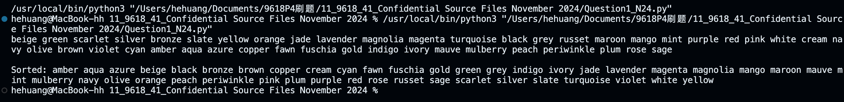

Question 2
Part 2(a)(i)
{Copy and paste program code listing for question 2(a)(i) here}

class Horse:
def __init__(self,n,mfh,ps):
self.__Name=n # PRIVATE Name: STRING
self.__MaxFenceHeight=mfh # PRIVATE MaxFenceHeight: INTEGER
self.__PercentageSuccess=ps # PRIVATE PercentageSuccess: INTEGER

Part 2(a)(ii)
{Copy and paste program code listing for question 2(a)(ii) here}

def GetName(self):
return self.__Name
def GetMaxFenceHeight(self):
return self.__MaxFenceHeight

Part 2(b)(i)
{Copy and paste program code listing for question 2(b)(i) here}

#main
Horses=[] # DECLARE Horses: ARRAY[0:1] OF Horse
Horses.append(Horse("Beauty",150,72))
Horses.append(Horse("Jet", 160, 65))
for horse in Horses:
print(horse.GetName())

Part 2(b)(ii)
{Copy and paste the screenshot for question 2(b)(ii) here}

Part 2(c)(i)
{Copy and paste program code listing for question 2(c)(i) here}
class Fence:
def __init__(self,h,r):
self.__Height=h # PRIVATE Height: INTEGER
self.__Risk=r # PRIVATE Risk: INTEGER

def GetHeight(self):
return self.__Height
def GetRisk(self):
return self.__Risk

Part 2(c)(ii)
{Copy and paste program code listing for question 2(c)(ii) here}

#main
Horses=[] # DECLARE Horses: ARRAY[0:1] OF Horse
Horses.append(Horse("Beauty",150,72))
Horses.append(Horse("Jet", 160, 65))
for horse in Horses:
print(horse.GetName())
print("")
Course=[] # DECLARE Course: ARRAY[0:3] OF Fence
for i in range(4):
Valid=False
while not Valid:
h=int(input("Enter the height of the fence in cm (Must between 70 and 180 inclusive). "))
r=int(input("Enter the risk number of the fence (Must between 1 and 5 inclusive). "))
if h>=70 and h<=180 and r>=1 and r<=5:
Valid=True
Course.append(Fence(h,r))
else:
print("Invalid height or risk number.")

Part 2(d)
{Copy and paste program code listing for question 2(d) here}

def Success(self,h,r):
Probability=self.GetMaxFenceHeight()*0.2
if h<=self.GetMaxFenceHeight():
if r==1: Probability=self.__PercentageSuccess*1.0
elif r==2: Probability=self.__PercentageSuccess*0.9
elif r==3: Probability=self.__PercentageSuccess*0.8
elif r==4: Probability=self.__PercentageSuccess*0.7
elif r==5: Probability=self.__PercentageSuccess*0.6
return Probability

Part 2(e)(i)
{Copy and paste program code listing for question 2(e)(i) here}
for j in range(2):
for k in range(4):
print(f"The horse {Horses[j].GetName()} at Fence {k+1} has a {Horses[j].Success(Course[k].GetHeight(),Course[k].GetRisk())}% chance of success")

Part 2(e)(ii)
{Copy and paste program code listing for question 2(e)(ii) here}

Avgs=[]
for j in range(2):
sum=0
for k in range(4):
print(f"The horse {Horses[j].GetName()} at Fence {k+1} has a {Horses[j].Success(Course[k].GetHeight(),Course[k].GetRisk())}% chance of success")
sum+=Horses[j].Success(Course[k].GetHeight(),Course[k].GetRisk())
Avgs.append(sum/4)
print(f"The horse {Horses[j].GetName()} has an average {Avgs[j]}% chance of jumping all four fences")
if Avgs[0]>Avgs[1]:
print(f"The horse {Horses[0].GetName()} has the highest average chance of success")
else: print(f"The horse {Horses[1].GetName()} has the highest average chance of success")

Part 2(e)(iii)
{Copy and paste the screenshot for question 2(e)(iii) here}

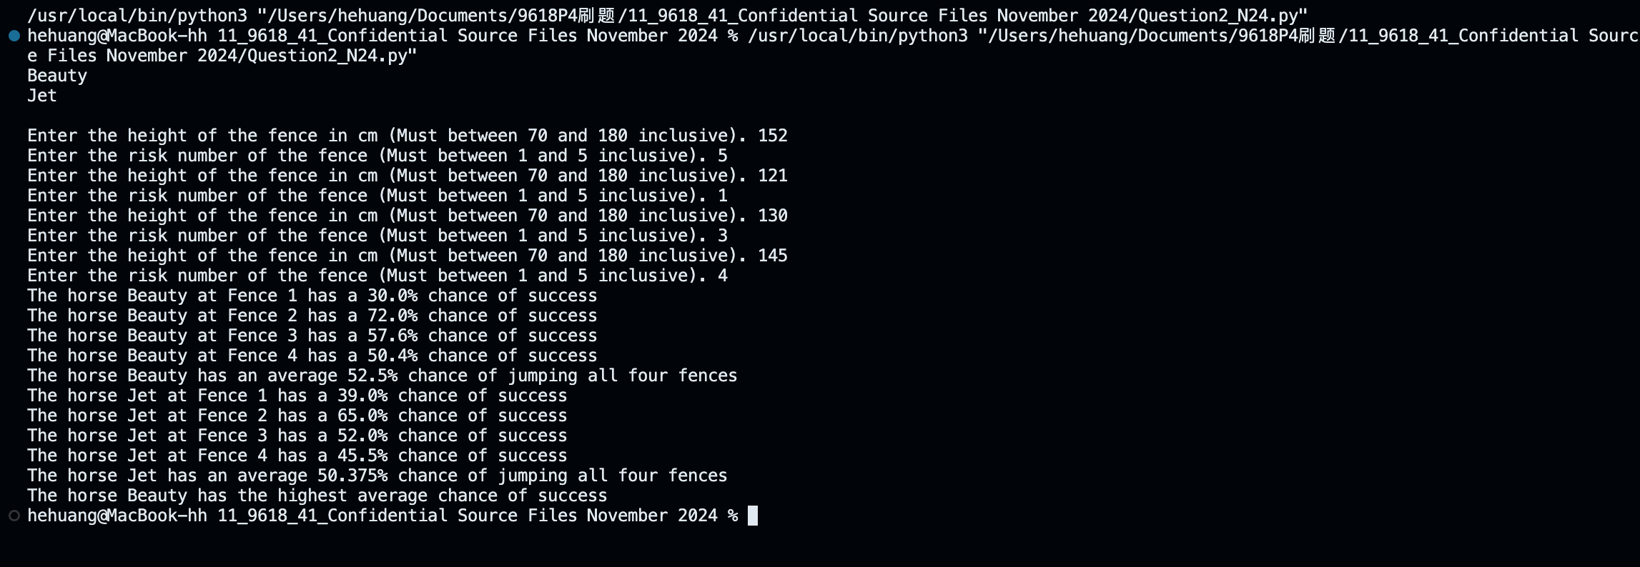

Question 3
Part 3(a)
{Copy and paste program code listing for question 3(a) here}
global LinkedList # DECLARE LinkedList: ARRAY[0:19, 0:1] OF INTEGER
global FirstEmpty # DECLARE FirstEmpty: INTEGER
global FirstNode # DECLARE FirstNode: INTEGER

#main
LinkedList=[[-1,i+1] for i in range(20)]
LinkedList[19][1]=-1
FirstEmpty=0
FirstNode=-1

Part 3(b)
{Copy and paste program code listing for question 3(b) here}

d def InsertData():
global LinkedList
global FirstEmpty
global FirstNode

for j in range(5):
Num=int(input("Enter a positive integer. "))

if not FirstEmpty == -1:
LinkedList[FirstEmpty][0]=Num
temp=LinkedList[FirstEmpty][1]
LinkedList[FirstEmpty][1]=FirstNode
FirstNode=FirstEmpty
FirstEmpty=temp
else:
break

Part 3(c)(i)
{Copy and paste program code listing for question 3(c)(i) here}

def OutputLinkedList():
global LinkedList
global FirstEmpty
global FirstNode

i=FirstNode
while i!=-1:
print(LinkedList[i][0])
i=LinkedList[i][1]

Part 3(c)(ii)
{Copy and paste program code listing for question 3(c)(ii) here}

#main
LinkedList=[[-1,i+1] for i in range(20)]
LinkedList[19][1]=-1
FirstEmpty=0
FirstNode=-1

InsertData()
OutputLinkedList()

Part 3(c)(iii)
{Copy and paste the screenshot for question 3(c)(iii) here}

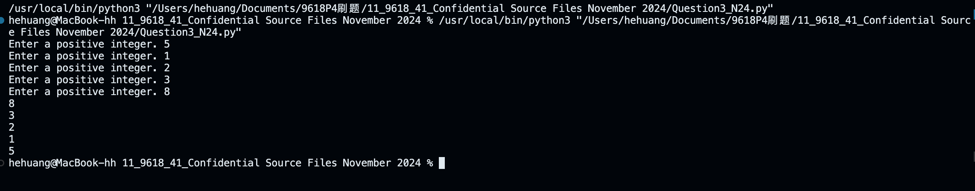

Part 3(d)(i)
{Copy and paste program code listing for question 3(d)(i) here}

def RemoveData(Num):
global LinkedList
global FirstEmpty
global FirstNode

Current=FirstNode
while Current!=-1:
if LinkedList[Current][0]==Num:
if Current==FirstNode:
FirstNode=LinkedList[Current][1]
else:
LinkedList[Last][1]=LinkedList[Current][1]
LinkedList[Current][1]=FirstEmpty
FirstEmpty=Current
break
else:
Last=Current
Current=LinkedList[Current][1]

Part 3(d)(ii)
{Copy and paste program code listing for question 3(d)(ii) here}

#main
LinkedList=[[-1,i+1] for i in range(20)]
LinkedList[19][1]=-1
FirstEmpty=0
FirstNode=-1

InsertData()
OutputLinkedList()
RemoveData(5)
print("After")
OutputLinkedList()

Part 3(d)(iii)
{Copy and paste the screenshot(s) for question 3(d)(iii) here}
